**VISVESVARAYA TECHNOLOGICAL UNIVERSITY**

**“Jnana Sangama”, Belgaum -590014, Karnataka.**



**PROJECT WORK-2 REPORT on**

**HOSTELITES**

***Submitted by***

**Naman Agarwal (1BM18CS057)**

**Nimit Sajal (1BM18CS063)**

**Parag Gattani (1BM18CS067)**

**Rutazeet Ritik Rout (1BM18CS151)**

***Under the Guidance of***

**Ishwari Ma’am**

## Professor, BMSCE

***In partial fulfillment for the award of the degree of***

**BACHELOR OF ENGINEERING**

***in***

### COMPUTER SCIENCE AND ENGINEERING



**B.M.S. COLLEGE OF ENGINEERING**

**(Autonomous Institution under VTU)**

### BENGALURU-560019 DEC 2019

**B. M. S. College of Engineering,**

**Bull Temple Road, Bangalore 560019**

(Affiliated To Visvesvaraya Technological University, Belgaum)

#### Department of Computer Science and Engineering



**CERTIFICATE**

This is to certify that the project work entitled “**HOSTELITES**” carried out by**Naman Agarwal (1BM18CS057), Nimit Sajal (1BM18CS063), Parag Gattani (1BM18CS067) and Rutazeet Ritik Rout (1BM18CS151)** who are bonafide students of B**. M. S. College of Engineering.** It is in partial fulfillment for the award of Bachelor **of Engineering in Computer Science and Engineering** of the Visveswaraiah Technological University, Belgaum during the year 2019. The project report has been approved as it satisfies the academic requirements in respect of **Project​Work-1 (19CS3PWPW1)** ​work prescribed for the said degree.

Signature of the Guide Signature of the HOD

Dr. Ishwari Dr. V. Umadevi

Professor Prof & Head of Dept of CSE

BMSCE, Bengaluru BMSCE, Bengaluru

External Viva

Name of the Examiner Signature with date

1._____________________________ ________________________

2._____________________________ ________________________

**B.M.S. COLLEGE OF ENGINEERING**

**DEPARTMENT OF COMPUTER SCIENCE AND ENGINEERING**



***DECLARATION***

We **Naman Agarwal (1BM18CS057), Nimit Sajal (1BM18CS063), Parag Gattani (1BM18CS067) and Rutazeet Ritik Rout (1BM18CS151)** students of 4th Semester, B.E, Department of Computer Science and Engineering, BMS College of Engineering, Bangalore, hereby declare that, this Project Work-w entitled “**HOSTELITES**” has been carried out by us under the guidance of Ishwari maam, Assistant Professor, Department of CSE, BMS College of Engineering, Bangalore during the academic semester Jan-Jun 2020.

We also declare that to the best of our knowledge and belief, the development reported here is not from part of any other report by any other students

**Signature:**

Naman Agarwal (1BM18CS057) Nimit Sajal (1BM18CS063)

Parag Gattani (1BM18CS067) Rutazeet Ritik Rout (1BM18CS151)

**TABLE OF CONTENTS**

|  |  |  |
| --- | --- | --- |
| **CHAPTER**  **NO.** | **TITLE** | **PAGE NO.** |
| 1 | **Introduction** | 1 |
| 1.1 | Overview | 1 |
| 1.2 | Motivation | 1 |
| 2 | **Software Requirement Specification** | 2 |
| 2.1 | Hardware Requirements | 2 |
| 2.2 | Software Requirements | 2 |
| 3 | **User Interface Design** | 3 |
| 3.1 | Login screen | 3 |
| 3.2 | Home Page | 5 |
| 3.3 | Events | 6 |
| 3.4 | Feedback | 8 |
| 3.5 | Facilities | 9 |
| 3.6 | Bank | 11 |
| 3.7 | Help | 12 |
| 3.8 | Food | 13 |
| 3.9 | Buy/Sell | 15 |
| 4 | **ER Diagram** | 18 |
| 5 | **Result And Conclusion** | 19 |
| 6 | **Future Enhancement** | 20 |

**Chapter 1**

## INTRODUCTION

### 1.1 Overview

We have made a fully functional and interactive Web-Portal for the B.M.S.C.E Hostilities that creates a platform that enables the students to know about the Hostels and full fill their basic needs, all at the comfort of their rooms. This website also provides better interaction between the management and the students, and also among students and the neighbourhood shopkeeper. It’s an easy way to provide students with the information about the in campus canteens and the mess, their menus and their timings on the go. Our website also aims at increasing the interaction between students as well as increase the participation of the students in various events happening all around the campus. We also believe in having a genuine feedback system so out portal allows students to register their feedbacks, complains and requests on various things including events, menus, facilities etc. to help improve the hostel experience for them. We also aspire to provide all the basic information like hostel facilities, bank facilities and basic contact number of wardens.

**1.2 Motivation**

Our main motivation is to help the new hostelites from all over the country and around the world settle in comfortably into the hostel culture and help them adapt to the lifestyle in any way possible. We hope to help students buy the basic needs that the parents panic about when a child gets to the hostel for the first time, including a mattress, electric kettle, a stand to hang clothes and much more. We aim to digitalize our hostel pinboards and get to everybody’s finger tips. To help everybody be up-to-date with the upcoming events, menus etc. We also focus on improving the student interaction amongst themselves and help bring the student and hostel administration closer with the help of regular feedback and recommendation system.

1

**Chapter 2**

## SOFTWARE REQUIREMENTS

**2.1 Hardware Requirements:**

* A PC with the following or greater specifications:
  + - Intel Core i3 (6​th​ gen or higher)
    - 4 GB RAM
    - 256 GB Hard Drive
* A stable internet connection (1Mbps or higher).

**2.2 Software Requirements:**

⚫ Operating system : Windows 8 or above

⚫ Technologies : HTML, CSS, JavaScript, PHP, My SQL

⚫ Browser : Google Chrome/Microsoft Edge / Mozilla Firefox

2

**Chapter 3**

## USER INTERFACE DESIGN

1. **Login/Signup page**

Our Sign-In and Sign-Up page heavily uses collapsible tables along with CSS, JavaScript and PHP to create new users as well as authenticate the existing users and log them in the home page. All the user information is validated and stored at the backend and all the passwords are hashed before storing into the database. There is an option to login as a normal user, admin user, vendors etc. with each type of login giving access to a limited number of features.

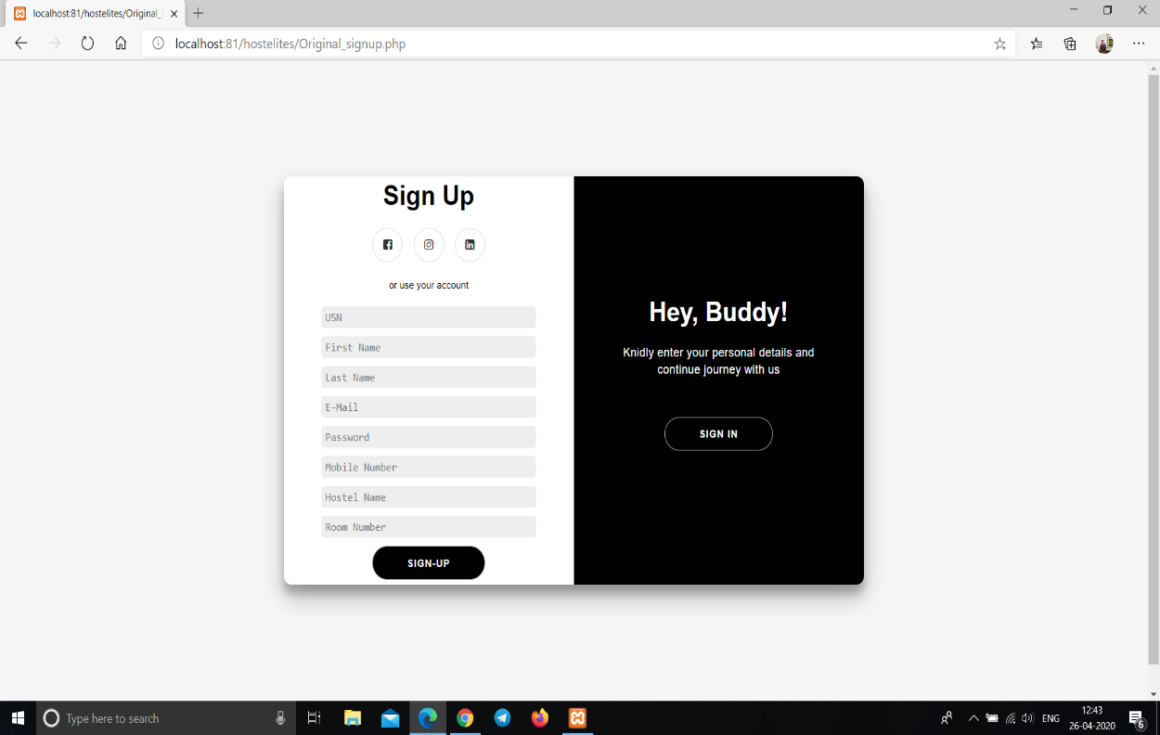

Fig 1. Sign Up page

3

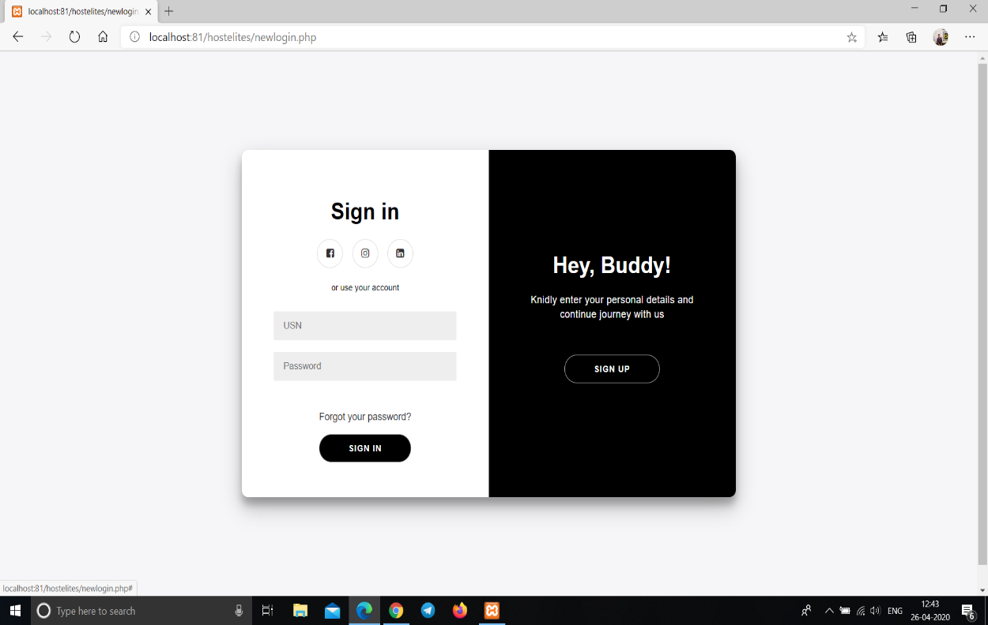 Fig 2. Sign In page

4

1. **Home Page**

Our homepage shows the basic details of all the inside campus as well as outside campus of B.M.S. Hostels as well as the details of each building under hostel department. It also acts as a link to all the other web pages.

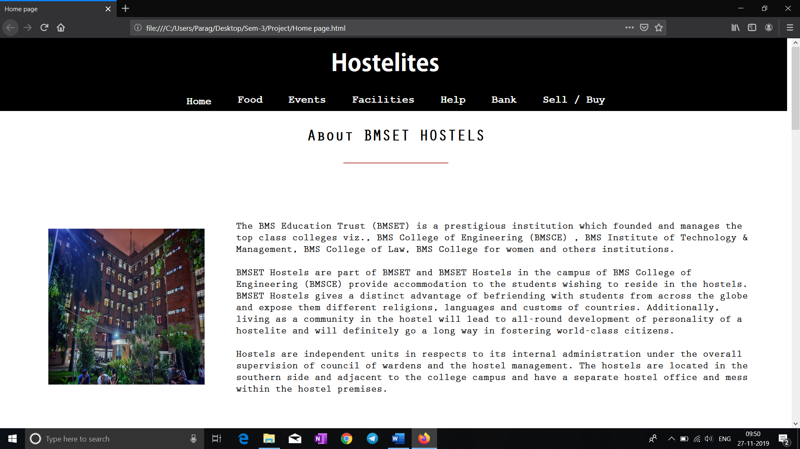

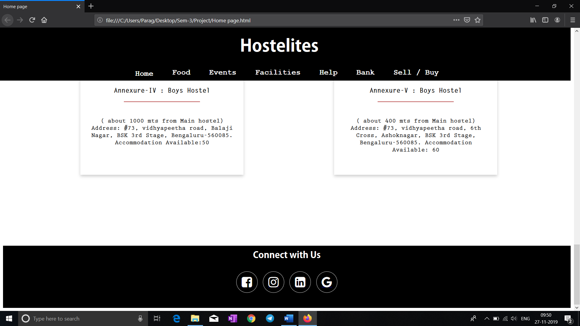

Fig 3. Home Page

5

1. **Events**

Our events page shows all the upcoming events that are being organized by the hostel committee or by individual students as well as a few details about them. The events page has option to host event available to all the students where they can add the name, date and time of the event and describe the event. The details then are verified by the Administrator and then the Event is hosted on the page.

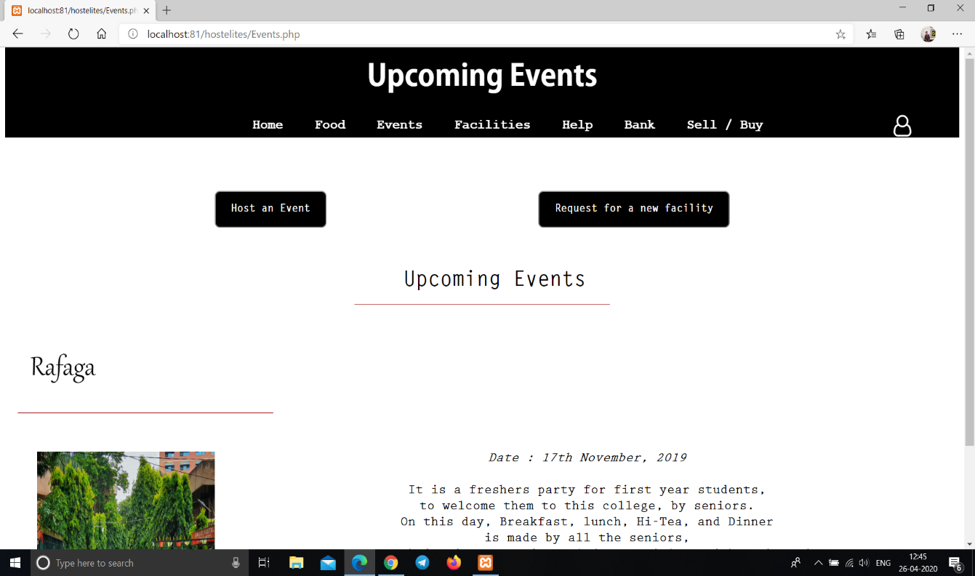

Fig 4. Upcoming Events Page

6

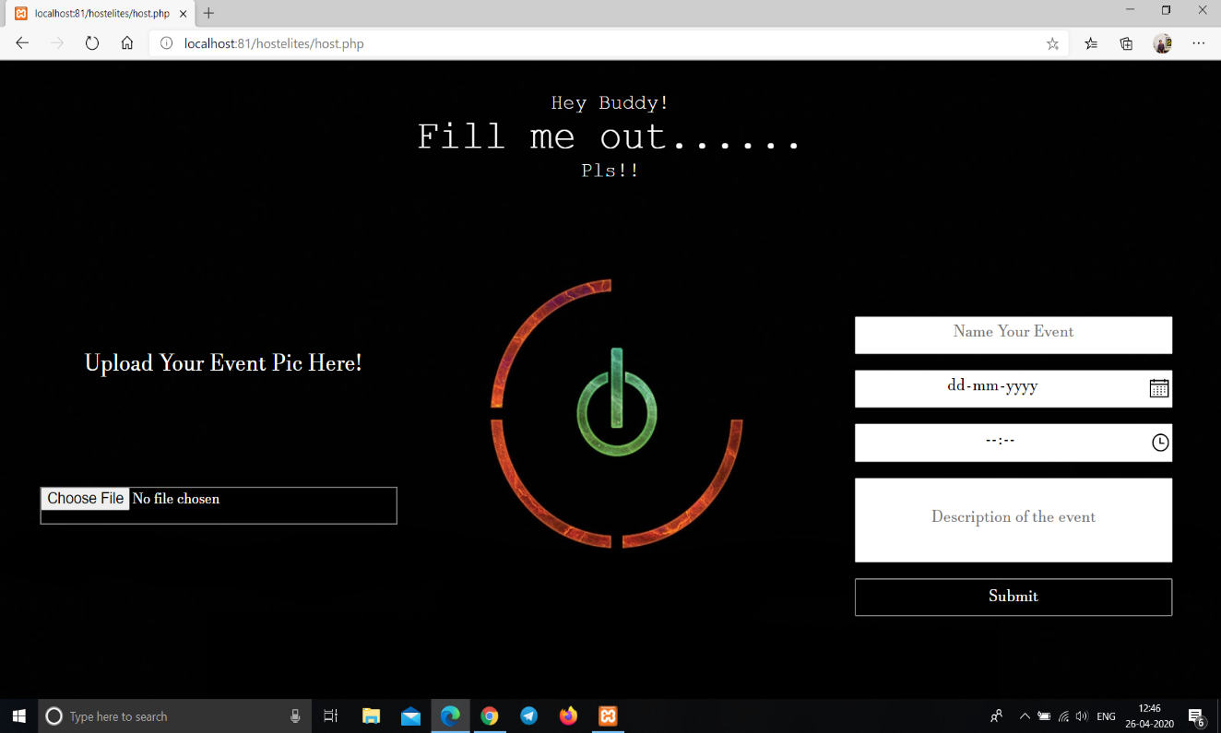

Fig 5. Host an Event Page

7

1. **Feedback**

Our feedback page takes the feedback of events, food items in the mess from the hostilities in the form of rating and conveys it to the administration.

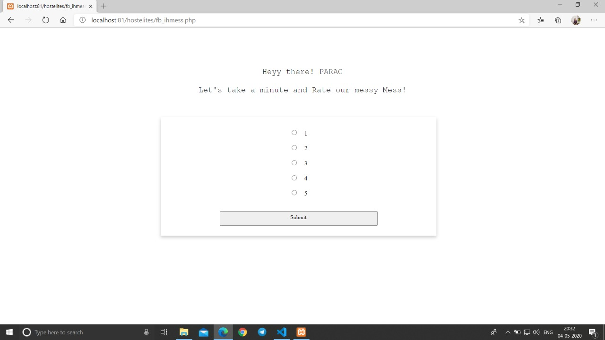

Fig 6. Feedback For Mess Food

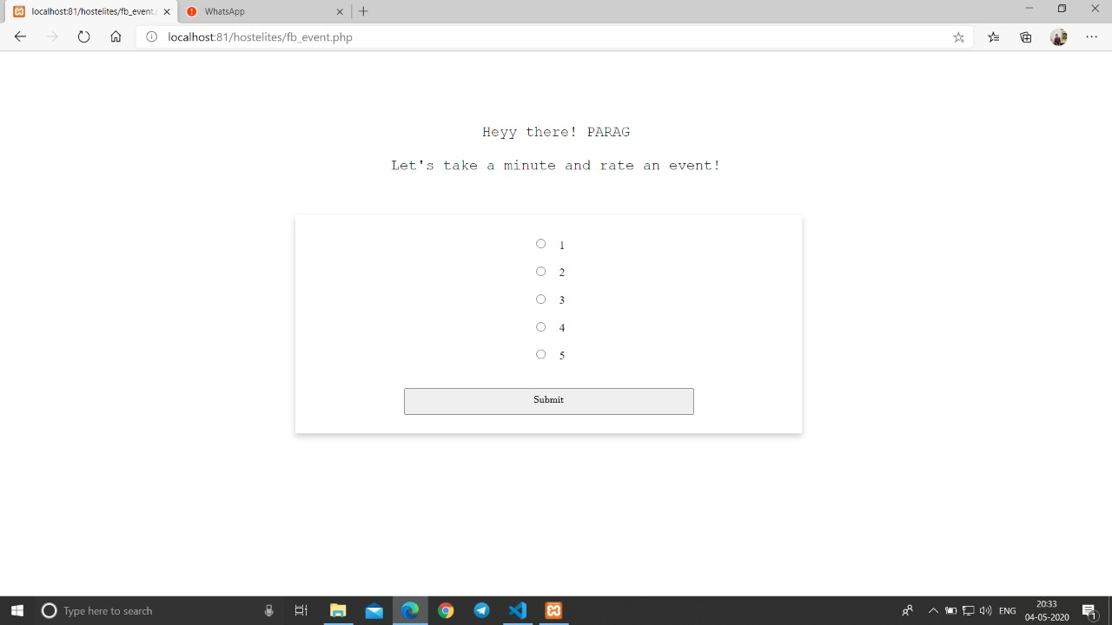

Fig 7. Feedback For An Even

8

1. **Facilities**

Our facilities page displays the different facilities readily available for students to use in the hostel. The student can request for a new facility or they can register a complaint of an existing facility as well.

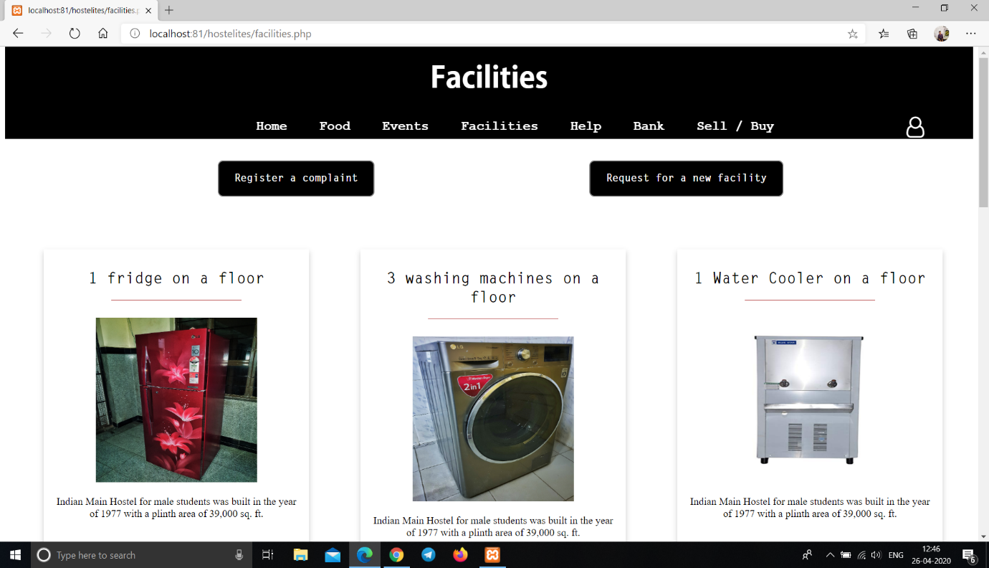

Fig 8. Facilities Available page

9

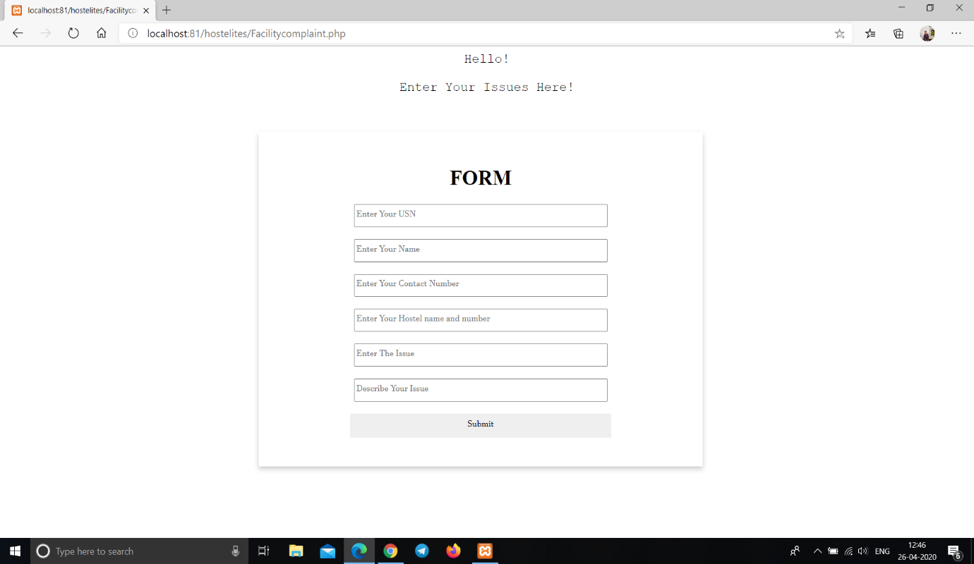

Fig 9. Host an Event Page

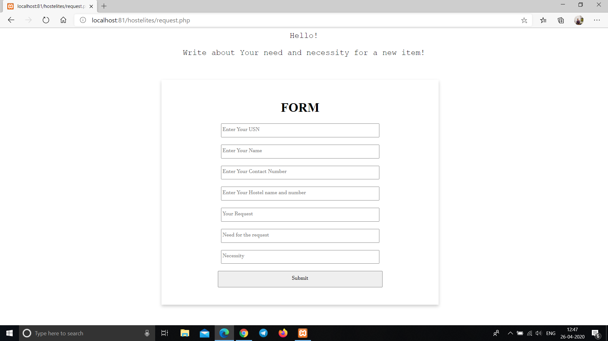

Fig 10. Request a Facility page

10

1. **Bank**

Our bank page shows the details for the in campus Allahabad bank such as IFSCE code, Bank timings etc. It also has a link to the banks official website for further clarifications.

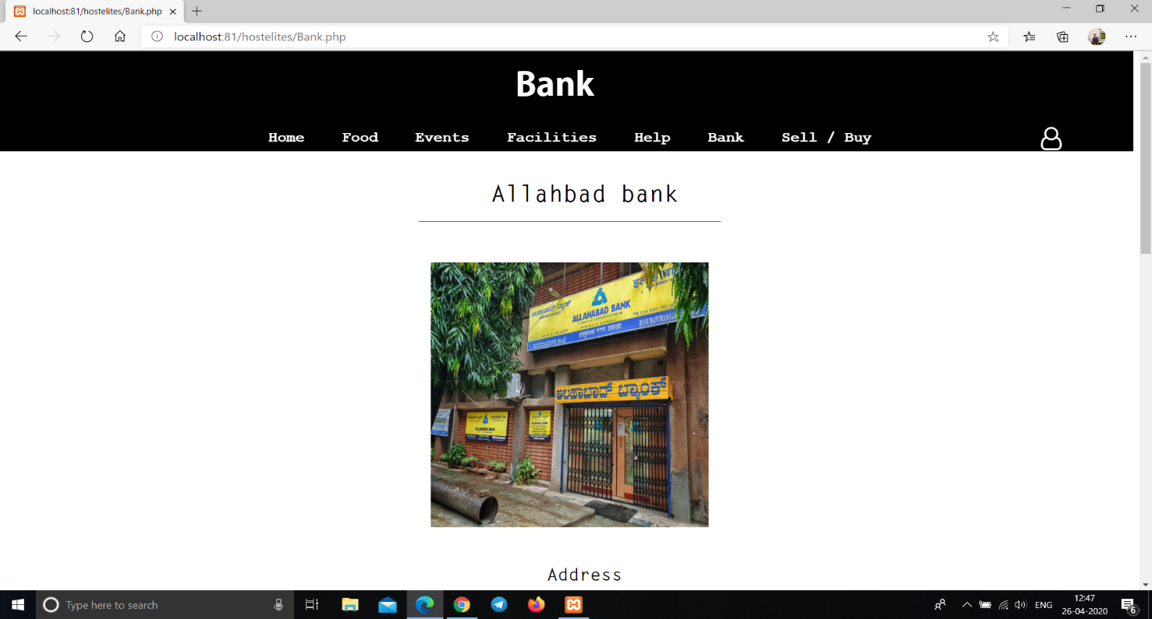

Fig 11. Information About Bank page

11

1. **Help Page**

Our help page is integrated with Google Maps and it displays a link for the Google Maps of the hostel as well as displays the telephone numbers of all the wardens with the functionality of calling them from the website itself.

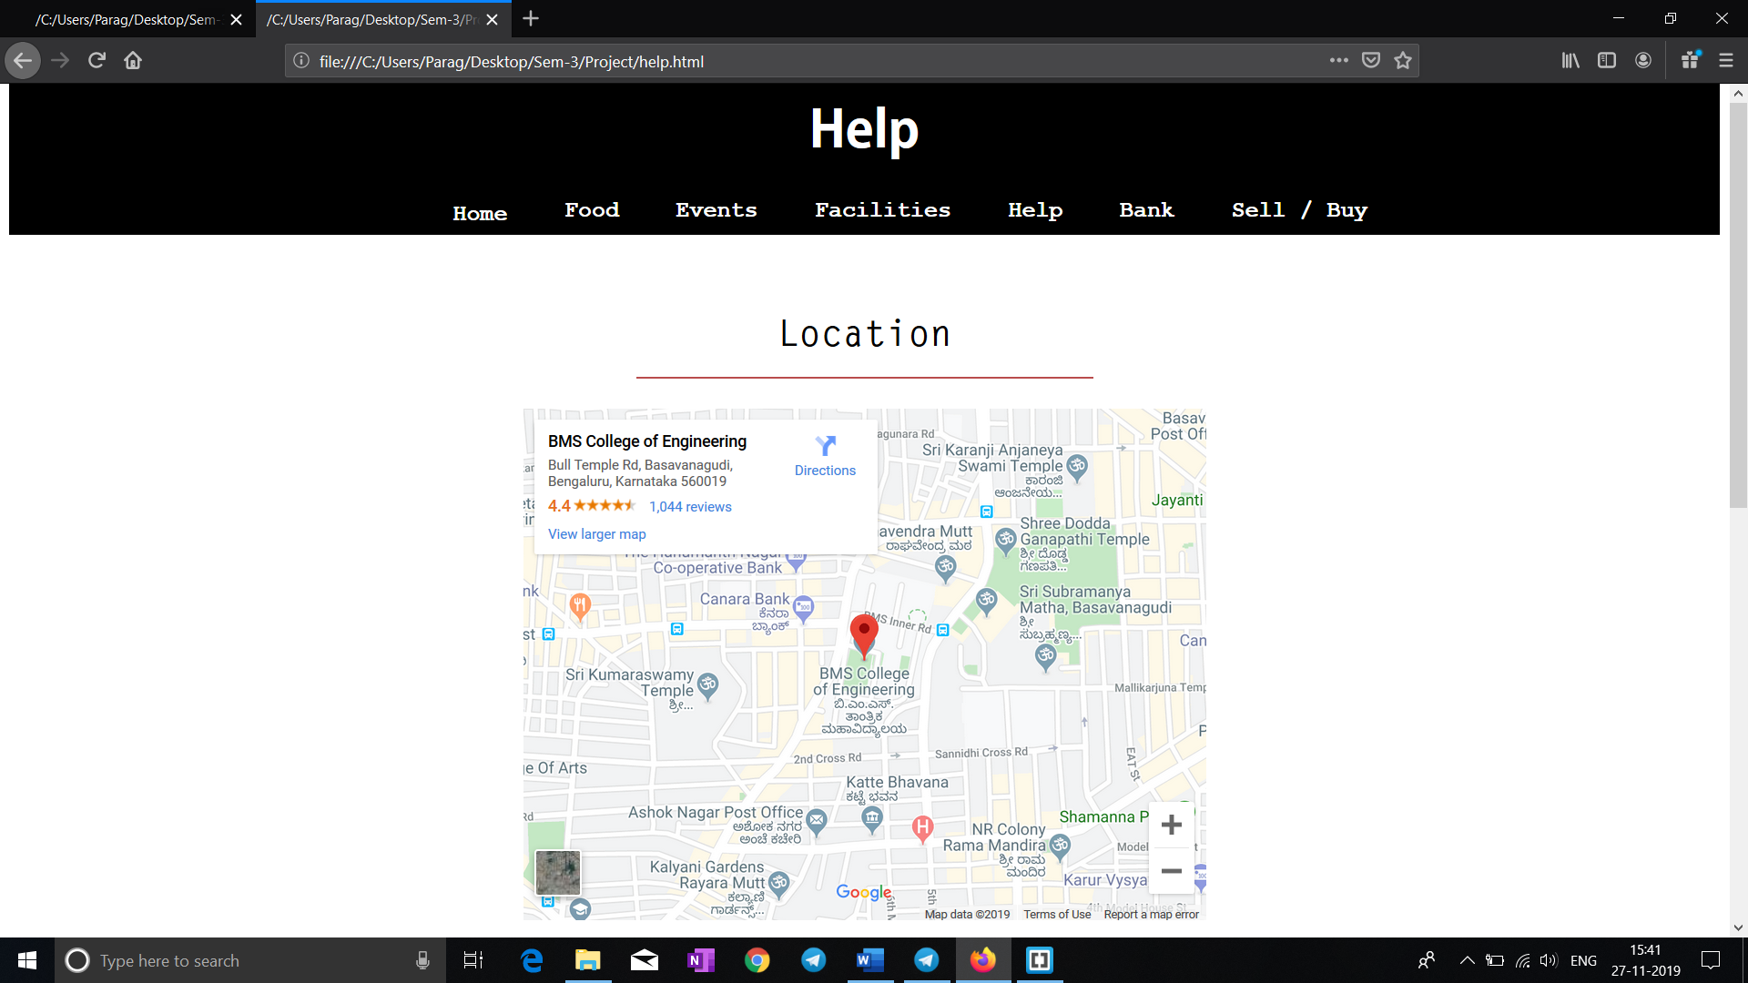

Fig 12. Help page

12

1. **Food**

Our food page displays the menu of each day of International Mess as well as the National Mess and the various canteens in the hostel vicinity.

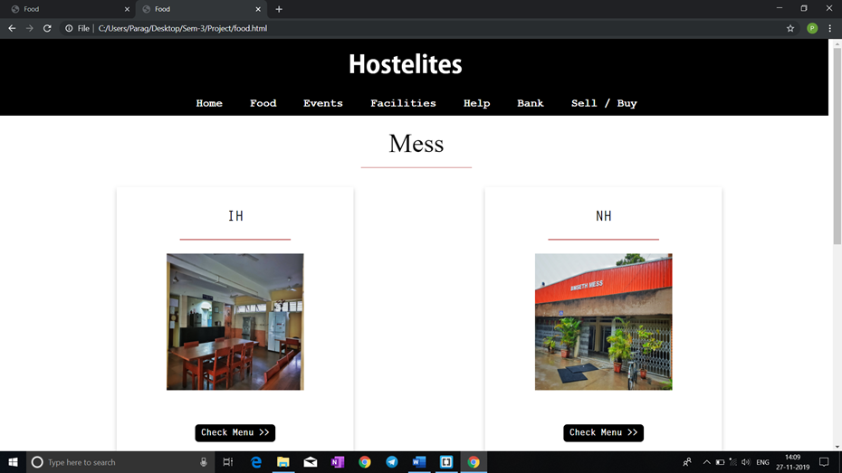

Fig 13. Food page

13

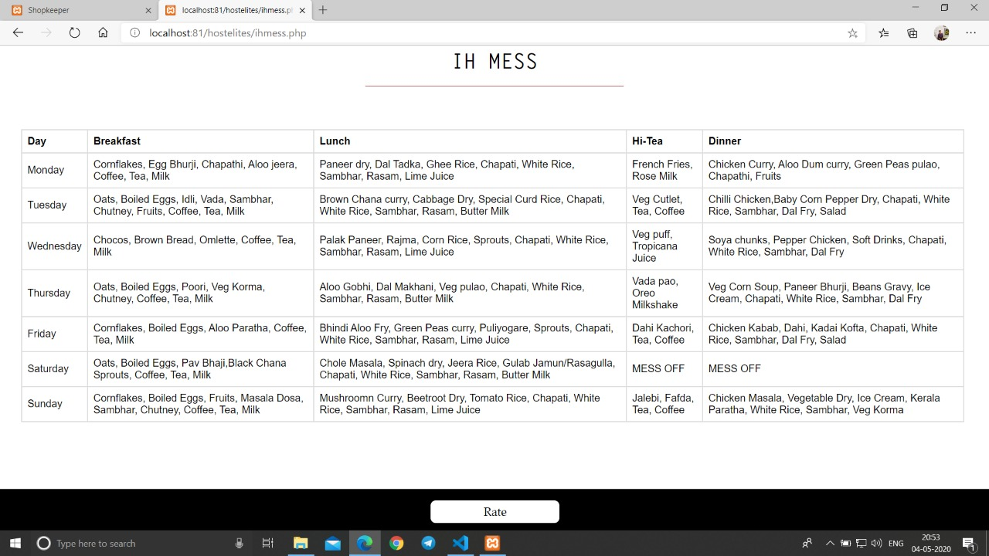

Fig 14. IH Mess Menu page

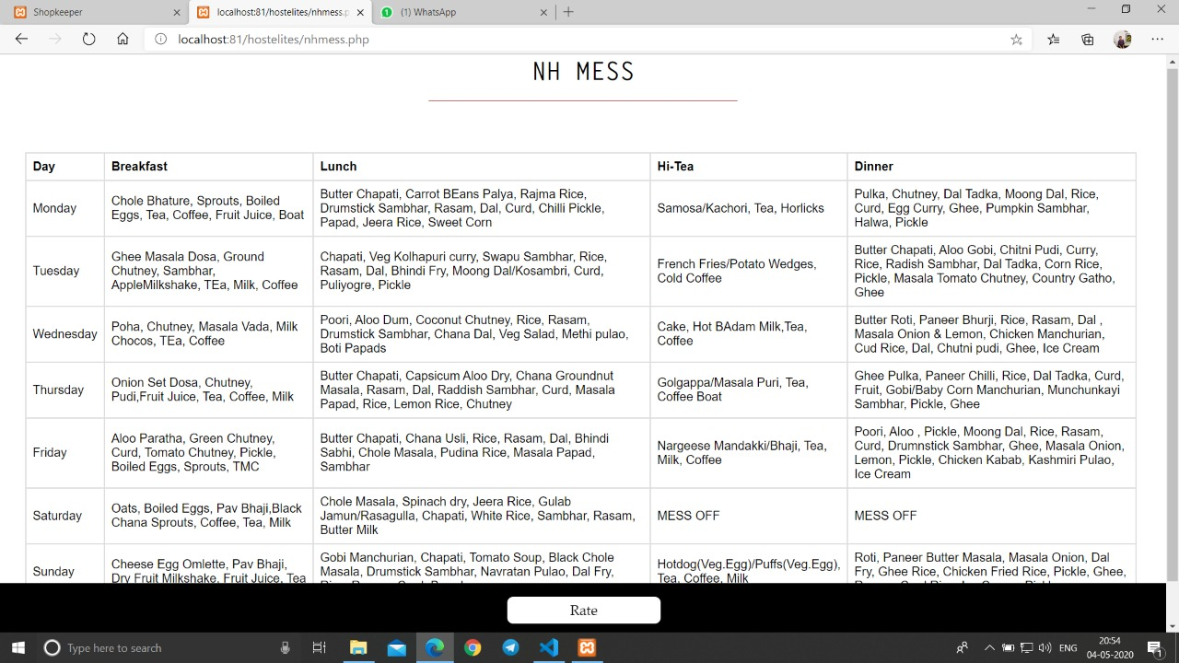

Fig 15. NH Mess Menu page

14

1. **Buy/Sell**

Our buy/sell page has an array of used as well as new items available for the user to buy with add to cart, remove from cart as well as view cart and clear cart functionalities. Here a student or a vender can even post their product details to be visible on the website for the students to easily access it.

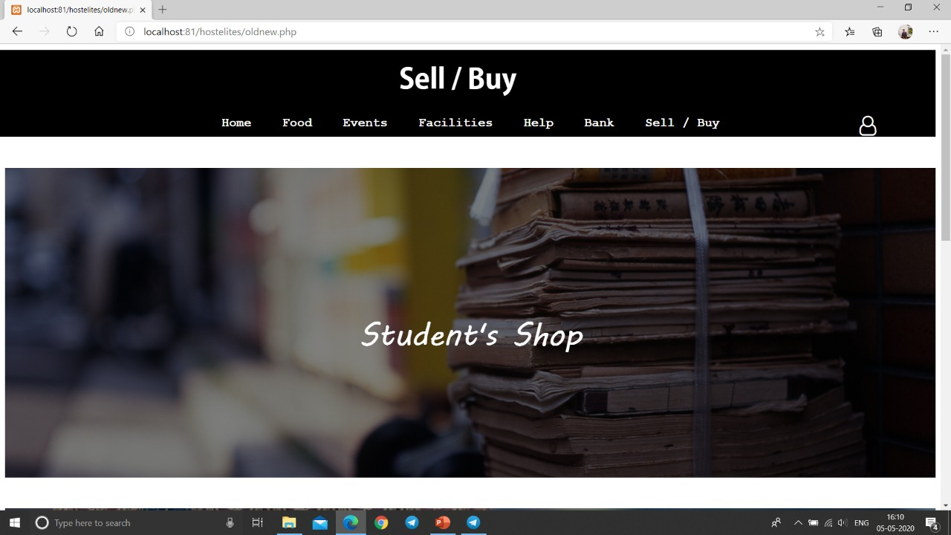

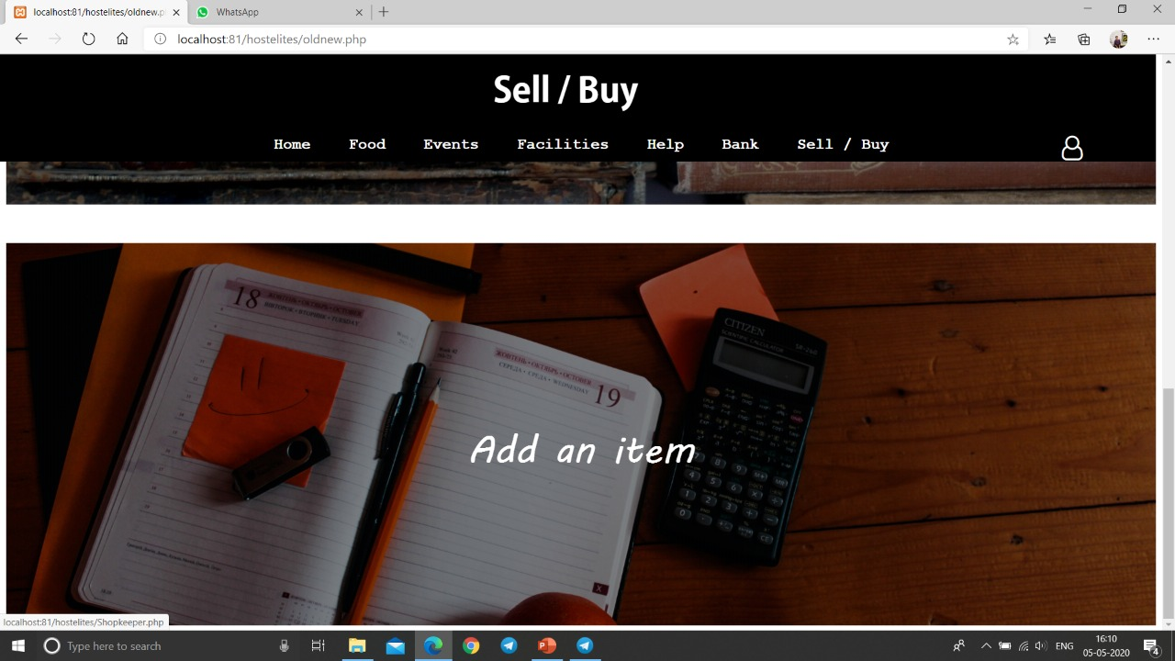

Fig 16. Buy/Sell page

15

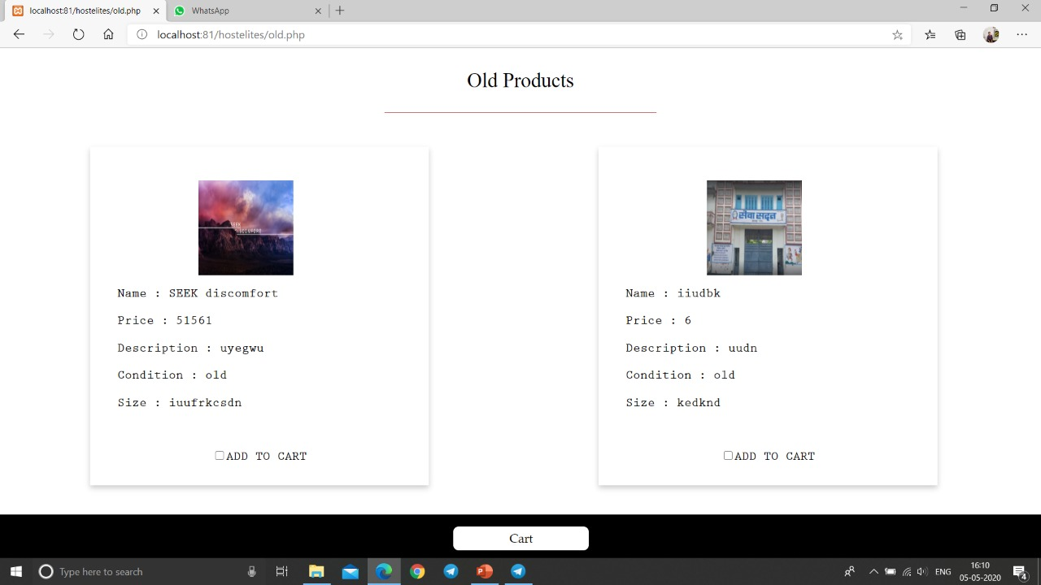

Fig 17. Old Items page

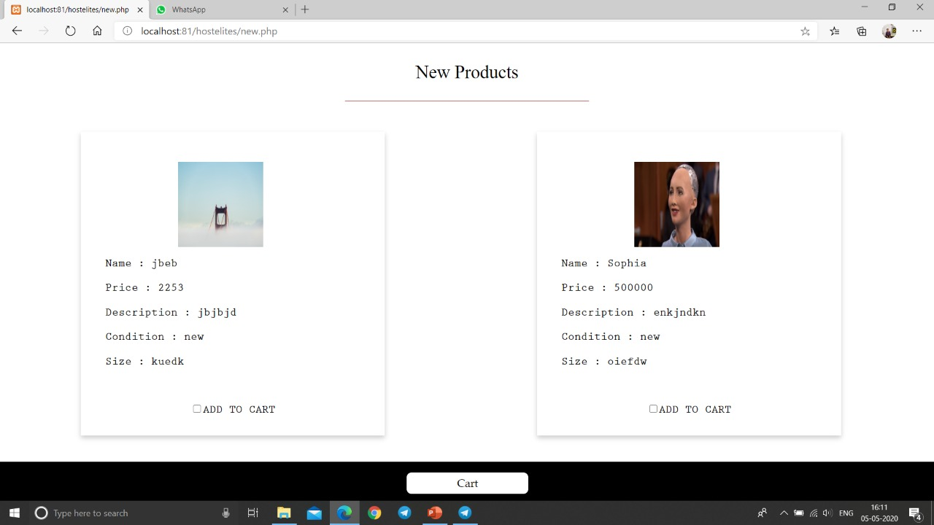

Fig 18. New Products Page

16

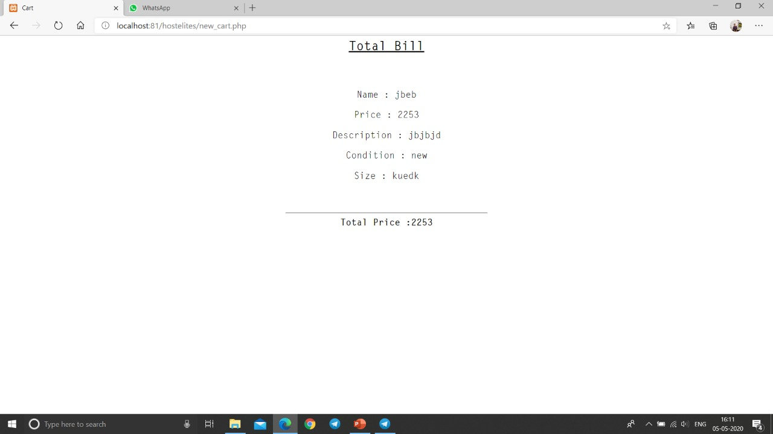

Fig 19. Final Cart page

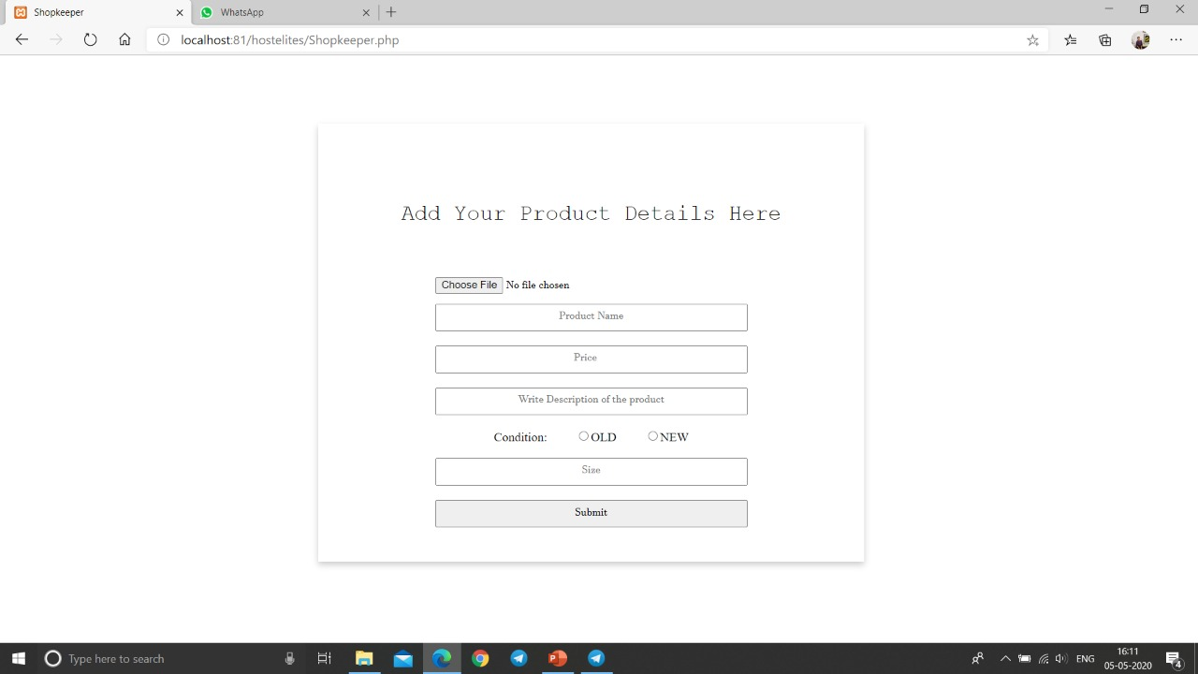

Fig 20. Add a New Product form

17

**Chapter 4**

**ER Diagrams**

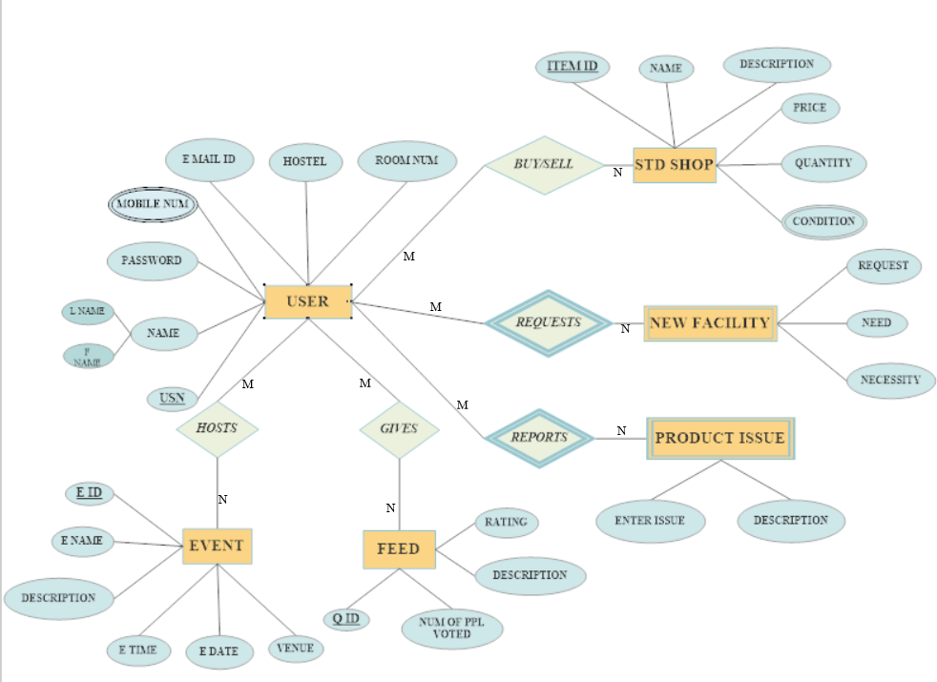

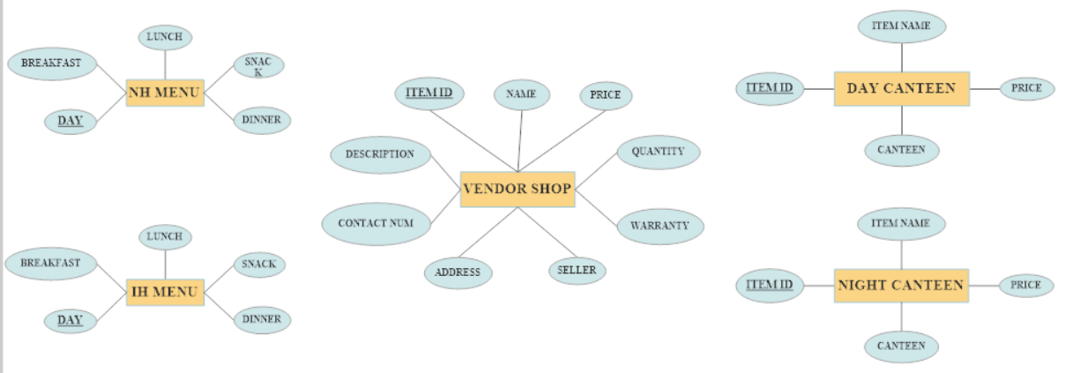

Fig 21. ER Diagram

18

**Chapter 5**

**Result And Conclusion**

We have made a fully functional and interactive Web-Portal for the B.M.S.C.E Hostilities that creates a platform that enables them to know about the Hostels.

Our project is extremely beneficial for freshers as it allows them to get acquainted with the hostel and feel it as their second home.

Our portal even allows the hostilities to easily communicate with the hostel management and provide them with their valuable suggestions.

Our portal also increases the participation among the residents, where they can buy and sell their items, hosts events, give feedbacks on the events and also decide menu, all in the comfort of their own room.

Our portal even allows the vendors to sell their goods using this portal and also allows the canteen owners to modify their items.

19

**Chapter 6**

**Future Enhancements**

Allow parents to see their wards daily attendance.

Provide real time FAQ and community post for better interactions among the juniors and the seniors.

Connect the neighbourhood food courts and allow delivery of those items.

Create play mates to play sports or do other activities together allowing better interactions among students and allowing them to make new friends and pursue their hobby.

20